[5:-10]

(array([-16.98297671, 21.97234596]), array([[ 0.01178934, -0.02748594],

[-0.02748594, 0.06415993]])) 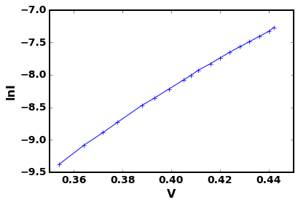

[6:-10]

(array([-16.96013481, 21.91938918]), array([[ 0.01128437, -0.02630564],

[-0.02630564, 0.06139639]])) 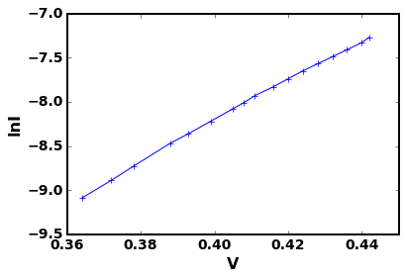

[7:-10] (array([-16.90831959, 21.79941639]), array([[ 0.01008025, -0.02349257],

[-0.02349257, 0.05481239]])) 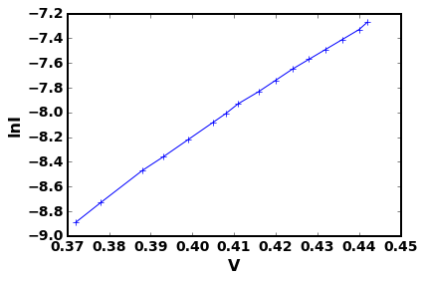

[8:-10] (array([-16.86118174, 21.69037654]), array([[ 0.0089823 , -0.020916 ],

[-0.020916 , 0.04875597]])) 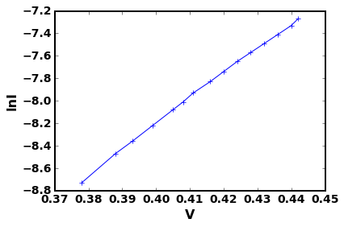

[9:-10] (array([-16.80989669, 21.57185294]), array([[ 0.00792835, -0.01845493],

[-0.01845493, 0.04299982]]))

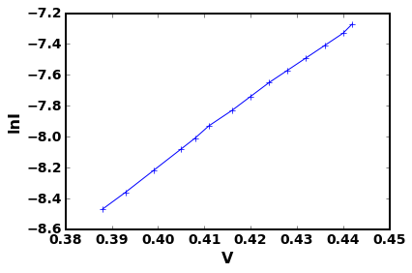

[10:-10] (array([-16.76957953, 21.478856 ]), array([[ 0.0085282 , -0.01982041],

[-0.01982041, 0.04610487]])) 